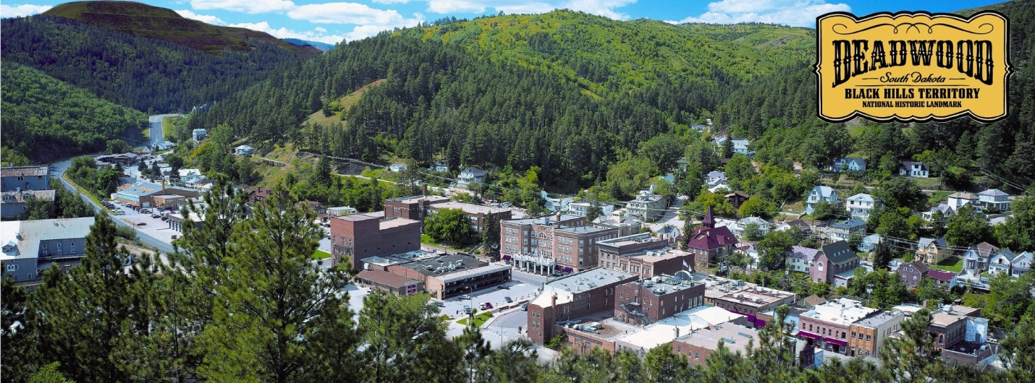
Welcome to Deadwood
Relocation Information
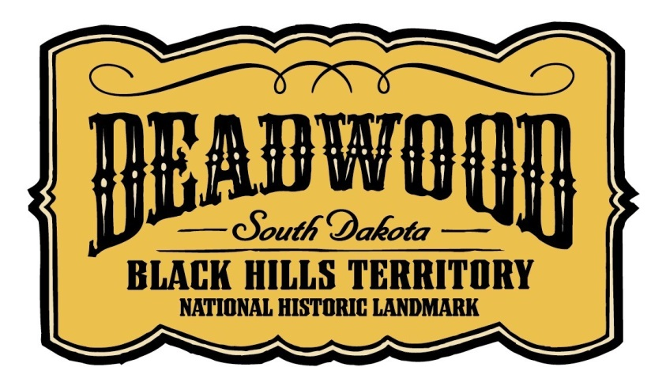
767 Main Street
Deadwood, SD 57732
(605) 578-1876 or (800) 999-1876
www.deadwood.org
Demographics
Deadwood, SD
Population:
Males: 663 | (52.5%)
Females: 600 | (47.5%)
Population in 2012: 1,263 (57% urban, 43% rural). Population change since 2000: -8.5%
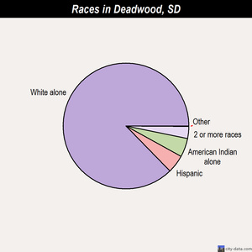
Median resident age: | 48.0 years
South Dakota median age: | 40.7 years
- White alone - 1,177 (92.7%)
- Hispanic - 43 (3.4%)
- Two or more races - 21 (1.7%)
- American Indian alone - 19 (1.5%)
- Asian alone - 6 (0.5%)
- Black alone - 3 (0.2%)
- Other race alone - 1 (0.08%)
Income:
Estimated median household income in 2011: $38,701 (it was $28,641 in 2000)
Deadwood: | $38,701
South Dakota: | $48,321
Estimated per capita income in 2011: $26,422
Mean prices in 2011:

All housing units: $131,148
Detached houses: $137,742
In 2-unit structures: $252,754
In 3-to-4-unit structures: $90,078
Mobile homes: $29,882
Estimated median house or condo value in 2011: $127,675 (it was $68,000 in 2000)
Deadwood: | $127,675
South Dakota: | $131,400
Median gross rent in 2011: $519
Information found at http://www.city-data.com/city/Deadwood-South-Dakota.html
Demographics
Lawrence County, SD

Population:
County population in 2012: 24,397 (63% urban, 37% rural)
Males: 11,935 | (44.5%)
Females: 12,162 | (55.5%)

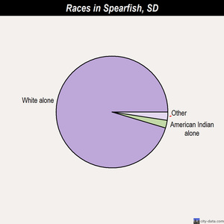
Population density: 30 people per square mile (low).
Races in Lawrence County, South Dakota:
- White alone - 9,863 (95.4%)
- American Indian alone - 231 (2.2%)
- Asian alone - 101 (1.0%)
- Two or more races - 79 (0.8%)
- Hispanic - 57 (0.6%)
- Black alone - 8 (0.08%)
Median resident age: | 41.0 years
South Dakota median age: | 36.0 years

Terrain:
Land area: 800 sq. mi.
Water area: 0.3 sq. mi.
The elevation of Deadwood is 4,533 feet above sea level.
Employment:
Industries providing employment:
Educational, health, and social services (21.3%)
Arts, entertainment, recreation, accommodation, and food services (18.9%).

Type of workers:
- Private wage or salary: 75%
- Government: 19%
- Self-employed, not incorporated: 6%
- Unpaid family work: 0%
Mar. 2012 cost of living index in Lawrence County: 83.8 (U.S. average is 100)
Information found at www.city-data.com/county/Lawrence_County-SD.html
Post-Secondary Education
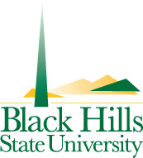
Black Hills State University
Spearfish, SD * Enrollment: 4,464
Black Hills State University is a master’s level university that promotes excellence in teaching and learning; supports research, creative and scholarly activities and provides service to the state, region, nation and global community. BHSU provides innovative, high quality undergraduate (associate and baccalaureate) programs in the arts, humanities, education, behavioral sciences, mathematics, social sciences, natural sciences, business and technology as well as selected disciplines of strength at the graduate level. Black Hills State University is the only comprehensive University in western South Dakota.

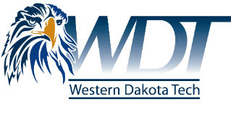
Western Dakota Technical Institute
Rapid City, SD * Enrollment: 1,115
Western Dakota Tech is a public institution of higher learning that embraces quality programs, expert faculty and staff, and a commitment to academic excellence to teach the knowledge, skills, and behaviors students need to be successful.

The University Center
Rapid City, SD * Enrollment: 1,700
Rapid City represents a partnership among South Dakota’s six public universities working cooperatively to deliver accessible, high-quality education in one convenient location.

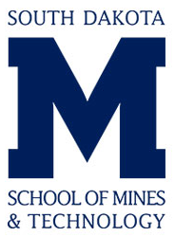
SD School of Mines & Technology
Rapid City, SD * Enrollment: 2,640
Founded in 1885, the South Dakota School of Mines & Technology is a science and engineering research university located in Rapid City, South Dakota, offering bachelor’s, master’s and doctoral degrees. For the 2013-1014 academic year, the university enrolls 2,640 students from 45 states and 37 countries, with a student-to-faculty ratio of 14:1. The average starting salary for graduates is $62,400 with a 98 percent placement rate.

Distances to Post-Secondary Education
Black Hills State University 18 miles
Western Dakota Technical Institute 48 miles
The University Center 48 miles
SD School of Mines & Technology 48 miles

Employment Services
South Dakota Dept. of Labor, Spearfish (605) 642-6900
Black Hills Special Services (605) 347-2531

Occupational Wages
Wages for Select Occupations in West Region
Occupational Titles | SOC Code | Avg. Wage per Hour
Accountants and Auditors | 13-2011 | $25.80
Civil Engineers | 17-2051 | $33.25
General and Operations Managers | 11-1021 | $48.88
Computer Programmers | 15-1131 | $24.55
Web Developers | 15-1134 | $19.83
Receptionists and Information Clerks | 43-4171 | $10.89
Retail Salespersons | 41-2031 | $13.62
Stock Clerks and Order Fillers | 43-5081 | $10.44
Bookkeeping Accounting and Auditing Clerks | 43-3031 | $13.84
Customer Service Representatives | 43-4051 | $13.58
Data Entry Keyers | 43-9021 | N/A
Executive Secretaries and Administrative Assistants | 43-6011 | $17.03
Sales Representatives, Wholesale and Manufacturing,  except Technical and Scientific Products | 41-4012 | $20.43
Construction Laborers | 47-2061 | $11.58
Packers and Packagers, Hand | 53-7064 | $8.83
Team Assemblers | 51-2092 | $12.78
Laborers and Freight, Stock and Material Movers, Hand | 53-7062 | $10.68
Stock Clerks and Order Fillers | 43-5081 | $10.44
Industrial Truck and Tractor Operators | 53-7051 | $14.21
Welders, Cutters, Solderers and Brazers | 51-4121 | $16.04
Industrial Machinery Mechanics | 49-9041 | $18.14
Medical and Clinical Laboratory Technologists | 29-2011 | $27.35
Computer Network Support Specialists | 15-1152 | $20.71
SOC: Standard Occupational Classification
The West Area consists of Bennett, Butte, Corson, Custer, Dewey, Fall River, Haakon, Harding, Jackson, Jones, Lawrence, Mellette, Perkins, Shannon, Stanley, Todd and Ziebach counties.
Source: Labor Market Information Center, South Dakota Department of Labor and Regulation, May 2014.

Employment by Industry
Lawrence County - Employment by Industry
2012 Annual Average
 | Industry | Workers
 | Services | 5,988
 | Government | 1,677
 | Trade | 1,577
 | Natural Resources/Mining/Construction | 838
 | Manufacturing | 496
 | Finance, Insurance and Real Estate | 377
 | Transportation/Warehousing and Utilities | 200

Labor
Labor Force/Employment/Unemployment
2013 Annual Average
County | Labor Force | Employed | Unemployed | Rate
Custer County | 4,650 | 4,450 | 200 | 4.3%
Lawrence County | 12,855 | 12,355 | 500 | 3.9%
Meade County | 12,670 | 12,150 | 520 | 4.1%
Pennington County | 55,055 | 52,945 | 2,110 | 3.8%
Totals | 85,230 | 81,900 | 3,330 | 3.9%
Source: Labor Market Information Center, South Dakota Department of Labor and Regulation, May 2014.
Labor Force/Employment/Unemployment March 2014
County | Labor Force | Employed | Unemployed | Rate
Custer County | 4,120 | 3,895 | 225 | 5.5%
Lawrence County | 12,940 | 12,380 | 560 | 4.3%
Meade County | 12,625 | 12,105 | 520 | 4.1%
Pennington County | 55,095 | 52,755 | 2,340 | 4.2%
Totals | 84,780 | 81,135 | 3,645 | 4.3%
Source: Labor Market Information Center, South Dakota Department of Labor and Regulation, May 2014.

Employment Statistics for Deadwood
Ten Largest Employers
May 2014

Firm | Type of Business | Employment
Lodge at Deadwood | Gaming/Hotel | 266
Deadwood Mountain Grand | Gaming/Hotel | 186
Silverado/Franklin | Gaming/Hotel | 174
Cadillac Jack’s/Springhill | Gaming/Hotel | 170
Wharf Resources | Mining | 170
Lead/Deadwood Schools | Education | 150
Sanford Lab | Scientific Research | 141
First Gold | Gaming/Hotel | 141
Northern Hills Hospital | Medical/Clinic | 130
City of Deadwood | Government | 128

Economic Development in Deadwood, SD

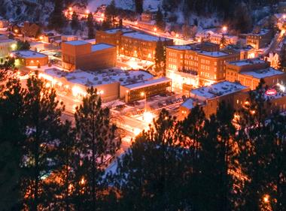
In addition to millions of annual visitors, Deadwood continues to attract residents and business people who seek a high quality of life and a favorable business climate. You’d be hard-pressed to find a safer—or more fun—place than Deadwood. Well-funded law enforcement agencies, excellent fire protection and a low population base keep crime down in the area. Deadwood and South Dakota are proud to be the ideal location for businesses to succeed. We have no corporate income tax, no personal income tax, no personal property tax, no inheritance tax and no business inventory tax. You don’t need a bunch of permits to do business in Deadwood, usually a sales tax license is all that is necessary. In any event, we will help you with any applications you need.
Deadwood Economic Development has its own Loan Program. We make loans to new manufacturing and retail businesses and existing operations that want to expand. In addition, there are loan programs available at the county, state and federal level, and DEDC will assist with all applications.

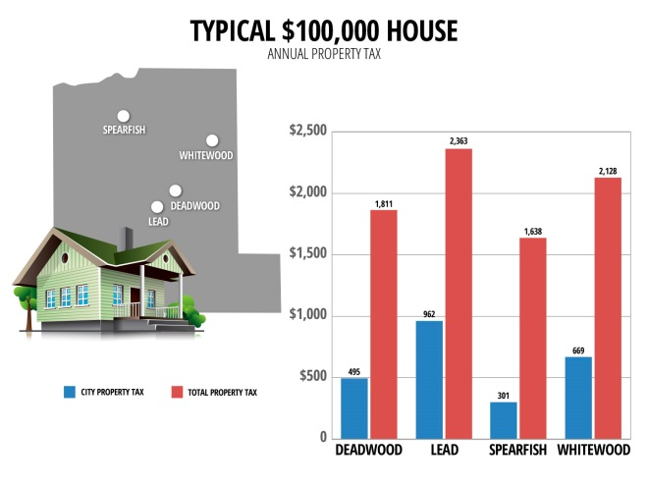
Churches and Schools in
Historic Deadwood

Churches:
St Ambrose Catholic Church Rectory
(605) 578-1519
760 Main St, Deadwood, SD
First Baptist Church
(605) 578-3660
110 Sherman St, Deadwood, SD
Grace Lutheran Church
(605) 578-2219
827 Main St, Deadwood, SD
St John's Episcopal Church
(605)920-8818
405 Williams St, Deadwood, SD
St Ambrose Parish
(605) 584-2002
760 Main St, Deadwood, SD
First Presbyterian Church
(605) 584-1455
12 Baltimore St, Lead, SD
St Patrick’s Church
(605) 584-3114
141 Siever St, Lead, SD
Real Life Community Church
(605) 571-0152
306 Mine St, Lead, SD
Lead Assembly of God Church
(605) 584-2960
105 Wall St, Lead, SD

Christ Church Episcopal
(605) 584-3607
631 W Main St, Lead, SD 57754
Shepherd of the Hills Lutheran Church
(605) 722-1206
825 W Main St, Lead, SD 57754
Twin Cities Church of Christ
(605) 584-2773
401 W Main St, Lead, SD 57754
Trinity United Methodist Church
(605) 584-1328
111 S Main St, Lead, SD 57754
Saddle Mountain Ministries
(605) 584-9982
21336 Saddle Mountain Pl, Lead, SD 57754
Schools:

Lead-Deadwood Elementary School
716 Main St, Deadwood, SD
(605) 717-3884

Enrollment: 377
Lead-Deadwood Middle School
234 South Main Street, Lead, SD
(605) 717-3898
Enrollment: 165

Lead-Deadwood High School
320 South Main Street, Lead, SD
(605) 717-3711
Enrollment: 215

Recreation & Entertainment in Deadwood, SD

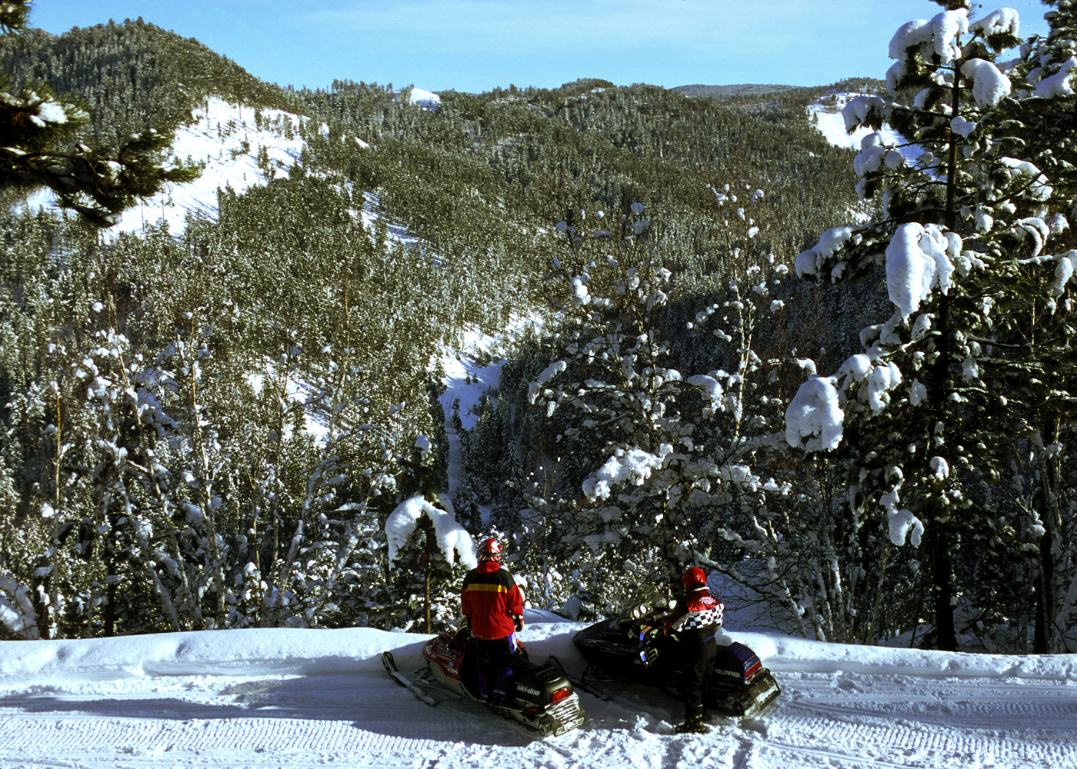
Deadwood offers a quality of life and recreational opportunities unmatched in major metropolitan areas. Surrounded by an emerald oasis known as the Black Hills, our residents find their greatest
satisfaction in doing business in a forest that spans more than a million acres (roughly the size of Delaware.) The location provides outstanding opportunities for mountain biking, hiking, snowmobiling, skiing, golfing, hunting, and fishing.
As it has for well over a century, Deadwood continues to serve as the entertainment and cultural capital of the region-providing concerts, theater, museums and year-round special events that capture the attention of thousands of visitors and the pleasure of local residents.

Quality of Life in Deadwood, SD

Lifestyle
Perched in the ponderosa pines, amid creek-carved canyons and alpine meadows, Deadwood allows residents to pursue activities and commerce in one of the most picturesque places in America.

Cost of Living
South Dakota residents enjoy all the amenities and one of the lowest cost of living allowances in the U.S.

Housing
Stately Victorian homes, apartments and well-kept houses mingle with parks and surrounding forest in Deadwood’s beautiful neighborhoods. Relocatees from out-of-state are often stunned by low housing costs in the Deadwood area.

Safety
You’d be hard-pressed to find a safer place than Deadwood, South Dakota. Well-funded law enforcement agencies, excellent fire protection and a low population base keep crime down in the area.

Health Care
Lead-Deadwood Regional Hospital, medical clinics and private practices provide immediate access to quality healthcare for Deadwood residents. Within an hour’s drive, locals also are served by medical centers specializing in the most advanced treatments of cancer, heart ailments and vision problems.

