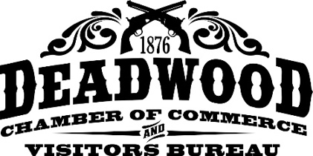

Dear Kool Deadwood Nites Enthusiast:

Thank you very much for your interest in Kool Deadwood Nites, August 19-24! We can’t wait to welcome you KDN veterans back and meet the “freshmen” too! This year’s fun starts Tuesday, August 19 with a show and shine on Main Street from 6-9 p.m. for registered cars only, entertainment and refreshments served at both Outlaw Square (The Drifters) from 5:30-7 p.m. and Mr. Wu’s (The Long Run “Colorado’s Tribute to the Eagles”) from 6-9 p.m. Refreshments and music are available Tuesday through Saturday from 2-9 p.m. Check out the enclosed flyer for more information. We’ll also begin registration on Tuesday from noon to 6 p.m. at the Deadwood Welcome Center, so feel free to come early!

New on Wednesday, August 20, cruise to Sturgis where registered car owners and a guest the Sturgis Show and Shine from 11-2 p.m. Then, head back to Deadwood; music by Surfin’ Safari starts at 6 p.m. ar Outlaw Square. Registration will be open from 8 a.m. to 6 p.m.

Our 18th annual Sock Hop and “People’s Choice Awards” at the History and Information Center Parking, Lower Main Street Parking Lot at the Deadwood Welcome Center lot, and portions of Historic Main Street will be on Thursday, August 21. Vote for your favorite classic car before heading to Main Street to take in the free entertainment on the Main Street stage, featuring Lovin’ Spoonful!

You can also register your car for the event on Thursday from 8 a.m. to 8 p.m. at the Deadwood Welcome Center in the lower Main Street Parking Lot. Enjoy various Poker Runs through the Black Hills on Thursday from noon to 5 p.m.

Friday, August 22 registration continues from 8 a.m. to 8 p.m. Register your beauty, pick up your goody bag, and talk to other car owners arriving in Deadwood. The 17th annual Rod Run will again feature two runs this year. Check out the flyer in the registration packet. The event runs from 10 a.m. to 2 p.m. with the Lodge at Deadwood offering free breakfast from 7 a.m. to 10 a.m. to all Rod Run registrants before the start of the event. Rod Run departs from the Days of ’76 Event Complex (Rodeo Grounds) at 10 a.m.

At 5 p.m. on Friday get ready to rock and roll with a night of free concerts on the Main Street stage, featuring some big-time bands, including Play Some Petty and Revisiting Creedence.

The fun continues Saturday, August 23 – starting with car judging at the Deadwood Days of ’76 Event Complex. Great sounds will fill the air from the Main Street stage again, featuring The Satin Dollz and 1964 The Tribute! Car registration is open from 7 a.m. to noon.

It’s time to show off your pride and joy on Sunday, August 24 with the annual parade in the morning before the Show and Shine and awards. Come and relive the koolest days of summer in Deadwood!

To check on room availability and we suggest you do it early, call 1-800-344-8826 or go to www.deadwood.com. We look forward to seeing you in August!

Jesse Allen

Event Coordinator

**2025 Kool Deadwood Nites**

**… changes & new stuff to be aware of!**

Registration for 2025 Kool Deadwood Nites will again be held at **Deadwood’s Welcome Center**! (501 Main Street, Deadwood, S.D. 57732) It is located in the Lower Main Street Parking Lot, across from Tin Lizzie.

Registration will begin at Noon on **Tuesday, August 19 from Noon-6 p.m.** for those who want to come early and get settled in! Several daily registration times changed in 2024. Check the schedule on page 3 for more information.

**On Tuesday, August 19** there will be a Show & Shine on Main Street from 6-9 p.m. for registered cars only. Outlaw Square will host free hot dogs and music featuring, “The Drifters” from 5:30-7 p.m. Mr. Wu’s will have a complimentary BBQ and music featuring, “The Long Run” from 6-9 p.m.

**All of** the Lower Main Street parking lot (location of the **Welcome Center**, where registration will be held) will be available to registered cars only Tuesday, Wednesday, Thursday, Friday, and Saturday, August 19-23. Of course, registrants can continue to park throughout the event at the History and Information Center too. **Please note there is no trailer parking in the Lower Main Street Parking lot.**

**Wednesday** the excitement continues with the Sturgis Show & Shine!

The driving Poker runs times have changed to Thursday from Noon-5pm.

There are two shuttles offered for parking this year, one from Cedar Rose Spa (Highway 14a, 1 mile north of Deadwood, formerly Akela Spa) and a second, new shuttle from Lead. The Lead shuttle picks up from Lead/Deadwood High School (320 S Main St., Lead) and the Sanford Lab Homestake Visitor Center (160 W Main St., Lead) and drops off at the Deadwood Fire Station (737 Main Street). **No trailer parking is available at either location.** This is a free service to all our guests for Kool Deadwood Nites. Hours are published on [www.DeadwoodCarShow.com](http://www.DeadwoodCarShow.com) and shuttles run continuously during this time.

The City of Deadwood Police Department asks that you please refrain from doing **Burnouts** during the parade on Sunday, August 24.

The Main Street Entertainment this year begins Wednesday, Aug 20; with Surfin’ Safari performing at Outlaw Square. Lovin’ Spoonful, takes the main stage Thursday, August 21; Revisiting Creedence, on Friday, August 22; and 1964 The Tribute on Saturday, August 23!

The official online home for Kool Deadwood Nites **merchandise** is [www.kooldeadwoodnitesofficial.com](http://www.kooldeadwoodnitesofficial.com) – see what’s in stock, because there’s A LOT! Merchandise options have expanded to include customizable items such as lettermen jackets, polo shirts, hoodies, sew-on patches and MUCH MORE! Head to the website and see what’s available!

*Please be aware of summer road construction projects.*

*Visit* [*www.sddot.com*](http://www.sddot.com) *for more information about state-wide project or* [*www.Deadwood.com-385-construction*](http://www.Deadwood.com-385-construction) *for alternative routes.*

**KOOL DEADWOOD NITES - 2025 Summary of Events -**

***\*Locations and Times are Subject to Change***

**Tuesday, August 19, 2025**

**Noon-6pm:** Car Registration –Lower Main Parking Lot @ Deadwood Welcome Center

**6-9pm:** Park your registered Classic Car on Main Street, betweenWall and Main.

**5:30-7pm: Outlaw Square will have free Hot dogs and entertainment featuring The Drifters.**

**6-9pm:** Mr. Wu’s will have a free BBQ and entertainment featuring The Long Run, Colorado's Tribute to the Eagles.

**Wednesday, August 20, 2025**

**8am-6pm:** Car Registration –Lower Main Parking Lot @ Deadwood Welcome Center

**11am-2pm:** Sturgis Show & Shine - Sponsored by Kool Deadwood Nites Official Merchandise and Sturgis Photos and Gifts

* For Registered Car Owners only. Participants must have wristbands and event registration information displayed on the car's dashboard. Registered car owners will receive a free commemorative item.
* Free Parking on Main Street from Junction Ave. to 4th Ave.
* 11 a.m. - 1 p.m. - Voting will take place for the Sturgis Choice Award
* 1 p.m. - Group Photo at 1st and Main St. The winner of the Sturgis Choice Award will be announced after the group photo.

**6pm:** Free Concert begins at Outlaw Square featuring Surfin’ Safari.

**Thursday, August 21, 2025**

**8am-8pm:** Car Registration –Lower Main Street Parking Lot @ Deadwood Welcome Center

**Noon-5pm:** DrivingPoker Runs – throughout the Black Hills

**4pm-9pm:** People’s Choice Awards & Voting – History and Information Center Parking Lot and portions of Deadwood Main Street

**4pm:** Classic Car Auction – Deadwood Mountain Grand. Call 605-348-1369 for more info

**8pm:** 18th Annual Sock Hop – Featuring Lovin’ Spoonful on Main Street Stage

**Following concert:** People’s Choice Award Results – Main Street Stage

**Friday, August 22, 2025**

**8am-8pm:** Car Registration –Lower Main Street Parking Lot @ Deadwood Welcome Center

**10am-2pm:** 17th Annual Rod Run

**9am:** Classic Car Auction – Deadwood Mountain Grand. Call 605-348-1369 for more info

**5pm:** Free Concerts – Music starts on Main Street – Featuring Revisiting Creedence

**Saturday, August 23, 2025**

**7am-noon:** Car Registration –Lower Main Street Parking Lot @ Deadwood Welcome Center

**7am-noon:** Classic Car Competition/Judging - Days of ’76 Event Complex

**9am:** Classic Car Auction – Deadwood Mountain Grand. Call 605-348-1369 for more info

**10am-4pm:** WalkingPoker Runs

**5pm:** Free Concerts – Music Starts on Main Street – Featuring 1964 The Tribute

**5pm:** Poker Run Awards party at Mr. Wu’s – Lower Main Street

**Sunday, August 24, 2025**

**7am:** Parade Line-up – Rodeo Grounds/Ferguson Field

**9am:** Parade - Main Street, continues through Central City & Lead.

**10am-2pm:** Show and Shine – Main Street – immediately following the parade until 2pm.

**11am:** Awards - Parking lot at the History and Information Center

**\*All cars must be off Main Street by 2 p.m. on Sunday, August 24, 2025! Thank you.**

**KOOL DEADWOOD NITES**

**17th Annual Rod Run**

***TWO routes again this year!!***

Join us Friday, August 22 for our 17th Annual Kool Deadwood Nites Rod Run. There are two options again this year:

* Enjoy an escorted tour through beautiful Spearfish Canyon with a stop at Carsten's Cottages including food and refreshments.
* OR head through Boulder Canyon, including a trip to Sturgis Drag Strip in Sturgis, for complimentary food, refreshments and you can even drive your car down the strip for a time trial!

-Each Rod Run will begin from The Days of 76 Event Complex. Line-up begins at 9am.

-The Rod Runs will run from 10 a.m. to 2 p.m.

-Enjoy food and refreshments upon arrival at each location.

***\*\*Please Note\*\****

-If you are taking the Spearfish Canyon route, there is a very small amount of gravel as you pull into the final stop at Carsten's Cottages. They will have food and drinks available when you arrive.

**Kool Deadwood Nites: Tips on Classifying Your Car**

**Stock** – which includes Stock Muscle, Stock Truck, Stock Tri-Five, and the 54’ – 73’ Stock class: must be as close to manufacture as possible including paint, interior, engine compartment so on and so forth. However, 3 small changes are allowed before deductions are added. Such as but not limited to chrome air cleaners, chrome valve covers, aluminum intakes, steering wheels, and things of that nature. We understand that rims can be ruined, and it is hard to find so major changes like that may be accepted as long as they are era correct. So be aware of what style of rims were made in these years. It is your responsibility to know these details.

**Modified** – which includes Modified Muscle, Modified Truck, and Modified Tri-Five: unlimited number of changes can be done as long as the body is not altered or changed in any way.

**Customs** – (49’ – 59’ and 60’ – 73’): a custom is when a body has been altered such as but not limited to shaved drip caps, door handles, French bumpers, and any body alterations of this nature from which the manufacture has produced your car.

**Pro Street** – a pro street car must have a larger than normal engine and tire configuration which would make the car above and beyond to be considered a normal street rod or muscle car.

**Street Rods** – (Pre 49’) Street rod is usually ground-up restoration with numerous alterations with the intent to make the car to be restored to modern conveniences.

**Truck** – Truck class may fit 4-wheel drives or 2-wheel drives. Some cars may look like trucks such as El Caminos, Rancheros, and larger trucks that may have duals would all fit in this class.

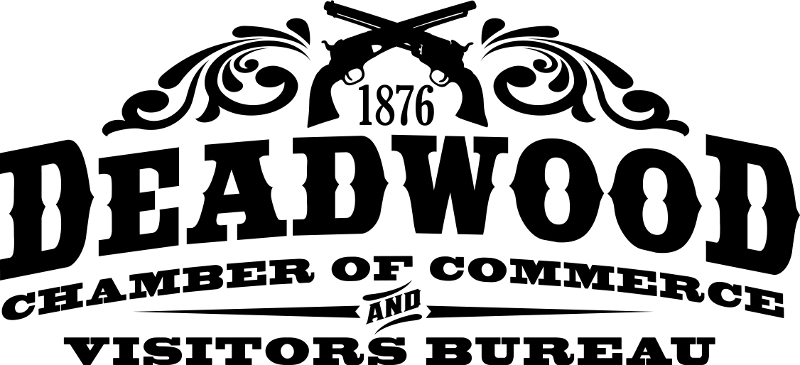

**Kool Deadwood Nites**

CLASSIC CAR JUDGING VEHICLE CATEGORIES

Please find the category that your vehicle fits and write the category on the enclosed registration form. If you have a question about what category you fit, we will have judges

on-site at registration to assist.

**Divisions include:**

**Street Rods – Pre ’49 (’48 and older) Customs**

• Coupe • Early ’49 to 59’

• Sedan • Late ’60 to 73’

• Roadster/Convertible

• RAT Rods

**Muscle Cars ’64 – ’73 Pro-Street**

• Stock • All – ’73 & earlier

• Custom

**Stock Truck Class ’73 & earlier**

• ’54 & older • Stock

• ’55 to ’73 • Custom – ’73 & earlier

**Tri-Five ’55 to ‘57**

• Stock

• Custom

Special Awards include: Committee’s Choice, Best Use of Color and Design, Best Interior, Best Motor, Best Street Rod, Best Custom, Best Stock, Best Truck, Best General Motors, Best Ford, Best MoPar, Chamber Choice and Honorable Mentions.

Call the Deadwood Chamber at 1-800-999-1876 for more info.

